# How to secure your environment

This guide was made to give complete information to ensure the safety of users and their wallets.

* First let's talk about security regarding Discord.

On Discord the DECENOMY team members will never start a private conversation first.

So if they approach you in private offering help, ignore the conversation and report the user in the channel #report-scammers-here.

* If in private someone sends you links with offers and promotions, please do not click them because you could run into misleading offers or possible scams.

Always report users who invite misleading advertisements in the channel #report-scammers-here.

* Do not open any files from private messages, almost always those who send files privately are trying to send malware or other software that may give access to your funds.
* We encourage you to always make sure to use only official links that you always find on our Discord.

For your safety we always suggest you to check the ID of the DECENOMY team members.

In Discord you can see the team ID in the dedicated channel #team-channel.

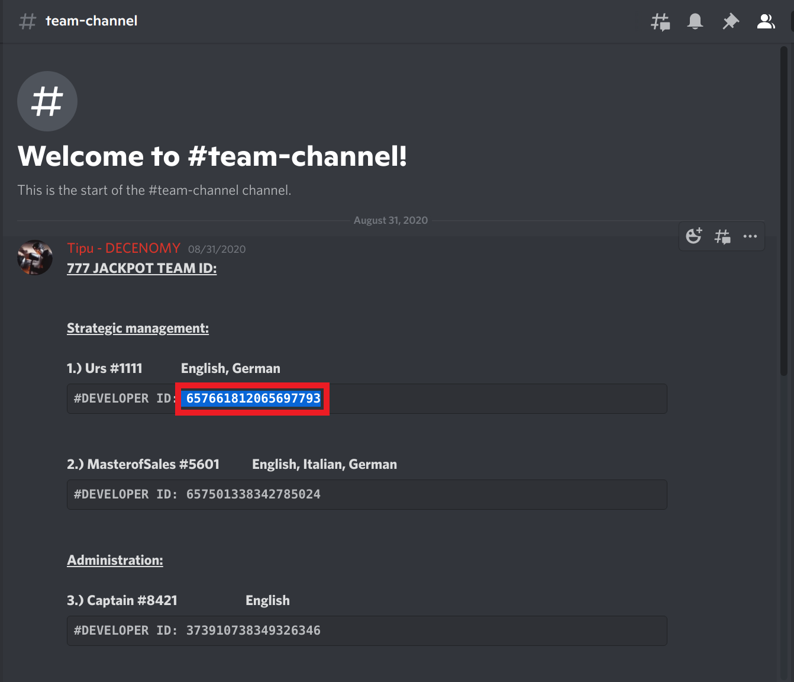

To check the ID of the user you are talking to, you can right-click on their username and then click on copy ID.

By doing this you can verify that it is the same as the ID in the team channel. (You might need to enable developer mode in Discord settings).

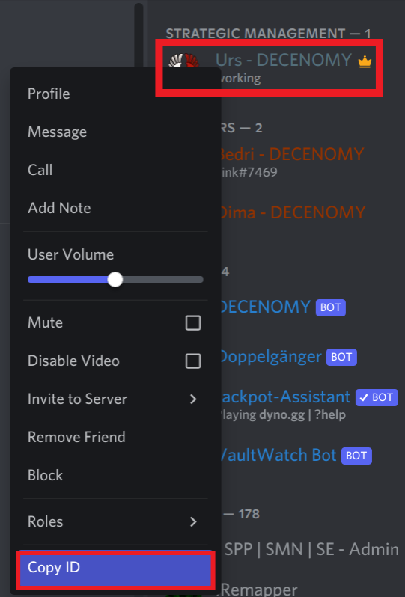

* The DECENOMY team recommends that you do not share sensitive data in public such as private keys, passwords, IP addresses.

Sharing a private key means giving access to one's own coins.

* Never trade on platforms such as DIscord but always use consolidated Exchanges.
* Trading coins privately is very risky as the other party may not make the payment and therefore scam you.
* Whenever possible start your software as a standard user and not as an administrator or root.

This helps prevent most possible attack vectors.

Make sure you have a good antivirus and anti-malware installed on your PC

* Do not allow any pc control or screen sharing via anyDesk, TeamViewer, remote desktop.  
  This way a potential hacker could steal your funds.

If you need help, always ask for it in the support channels.

* When you make a big transaction, or when you send a transaction to an address saved in your address book, try to send a control amount first. e.g. 10 SAPP, instead of 10k SAPP.
* Do not keep passwords in a text file on your desktop.

Write them on paper or store them in your USB stick.

* Secure the wallet with a password, and remember that the wallet.dat is the key to your money.

You need to have a few copies of that, each in different places.

* Never share the result of commands such as

**dumpwallet**

**dumpprivkey**

**backupwallet**

This guarantees access to your funds and thus being robbed.

* Always make sure you protect your accounts with two-factor authentication.
* Always use a different password in each website you register.

By following these simple rules you can be sure that your funds are safe.